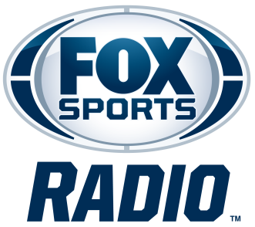

KELVIN WASHINGTON
BIOGRAPHY

Veteran sports media personality Kelvin Washington is co-host of FOX Sports Radio’s The Odd Couple. Joined by co-host Rob Parker, the program features dynamic discussion and outspoken opinions as the duo covers the biggest stories and headlines in sports. The Odd Couple with Rob Parker and Kelvin Washington broadcasts Monday through Friday from 7 to 10 p.m. ET on more than 430 radio stations nationwide, and can also be heard on FOX Sports Radio’s channel on iHeartRadio and FOXSportsRadio.com. Fans can also watch all three hours of The Odd Couple LIVE every day on their YouTube channel HERE, where they can also view clips and highlights from the show.
An Emmy Award-winning host and anchor for Spectrum News 1 Southern California, Washington has been with the network since its launch in 2018, covering the issues, events, and stories impacting communities throughout the region. In August 2024, he became host of Your Morning on Spectrum News 1, helping viewers start their day with news, interviews, and conversations that matter most to Southern Californians.
Washington is also a frequent contributor to LA Times Today and serves as one of the hosts of the pregame and postgame coverage for the Los Angeles Dodgers on SportsNet LA. A 2021 Golden Mike Award recipient, he has hosted a variety of original programs, documentaries, and special productions, including The Envelope: Emmy Roundtables and Spectrum News 1's Emmy-nominated 50 Years of Hip Hop: From the Westside.
Throughout his career, Washington has interviewed some of the biggest names in sports and entertainment, including Clayton Kershaw, Magic Johnson, Kareem Abdul-Jabbar, and Grant Hill.
Washington joined ESPNLA 710 in 2014 and became a fixture in Los Angeles sports radio. In 2015, he debuted Kelvin and Travis, a local morning drive show, before later co-hosting Marcellus and Kelvin and Afternoons with Marcellus, Kelvin and E.D. Prior to ESPNLA, he was an on-air personality for SiriusXM’s Radio Disney and 99.1 KGGI, an iHeartMedia station in Southern California.
In addition to his radio and television work, Washington co-hosted NBC's Spartan: Ultimate Team Challenge, a competition series that featured athletes and everyday competitors tackling demanding obstacle-course challenges for a chance to win a cash prize.
Known for his energy, authenticity, and ability to connect with audiences across multiple platforms, Washington has built a career spanning radio, television, sports, and entertainment. Whether covering breaking news, interviewing sports legends, or debating the latest headlines, he brings a unique perspective and passion to every broadcast.
Fans can follow Washington on X and Instagram.
# # #

